The scarlet thread of redemption

Scarlet (red) colored (dyed) fine twined linen was required for the curtains, vail, tabernacle door, the door of the gate, the priests holy garments, the ephod, and the curious girdle of the ephod.

Exodus 26:1
Moreover thou shalt make the tabernacle with ten curtains of fine twined linen, and blue, and purple, and scarlet^{H8438}: with cherubims of cunning work shalt thou make them.

Exodus 26:31 (36:35)
And thou shalt make a vail of blue, and purple, and scarlet^{H8438}, and fine twined linen of cunning work: with cherubims shall it be made:

Exodus 26:36 (36:37)
And thou shalt make an hanging for the door of the tent, of blue, and purple, and scarlet^{H8438}, and fine twined linen, wrought with needlework.

Exodus 27:16 (38:18)
And for the gate of the court shall be an hanging of twenty cubits, of blue, and purple, and scarlet^{H8438}, and fine twined linen, wrought with needlework: and their pillars shall be four, and their sockets four.

· The priests holy garments, the ephod, and the curious girdle of the ephod.
Exodus 28:4,5,6,8 (39:1-3,5,8,24,29)

It was also required for certain cleansing rituals:
- Cleansing of a leper and a house with leprosy (Leviticus 14).
- Purification from uncleanliness caused by a corpse (Numbers 19).

And also for the covenant at Mount Sinai:

Hebrews 9:16-19 (Exodus 24:3-8)
16 For where a testament is, there must also of necessity be the death of the testator. 17 For a testament is of force after men are dead: otherwise it is of no strength at all while the testator liveth. 18 Whereupon neither the first testament was dedicated without blood. 19 For when Moses had spoken every precept to all the people according to the law, he took the blood of calves and of goats, with water, and scarlet wool, and hyssop, and sprinkled both the book, and all the people,

So, where did they get the red dye for all these things? From a worm called the “crimson grub/scarlet worm/crimson worm” (Coccus ilicis). The dye was extracted from the dried remains of dead females. Females typically grow to a size of ~4mm long and ~3.5mm wide, which is about the size of an uncooked grain of rice or a small ladybug. With all the different things that needed red dye one can imagine that quite a few of them were required. Only one of the Hebrew words in the Bible that was translated to “worm(s)” is also sometimes translated as “crimson” or “scarlet” and that is H8438 תֹּולָע (tôwlâʻ | to-law') (typically pronounced “tolah” or “tola”). The first time it appears is in Job 25:6:

Job 25:6
How much less man, that is a worm^{H7415}? and the son of man, which is a worm^{H8438}?

The one we are interested in today is what Jesus calls Himself in Psalm 22:6 “But I am a worm^{H8438}…” as in the “scarlet worm” and not a maggot, a moth, or worms as it appears elsewhere. Why did He decide to call Himself this particular type of worm? He created all things (Colossians 1:16) and this particular worm is very special. But, to learn how, we have learn about the life cycle of it, particularly the female.
Before we continue though, there are some other things that we also need to understand first. The color red is the color of blood and it can be a symbol of life as in Genesis 9:4 and Leviticus 17:11a. Red (also known as scarlet/crimson in the Bible) can also represent sin as in Isaiah 1:18.

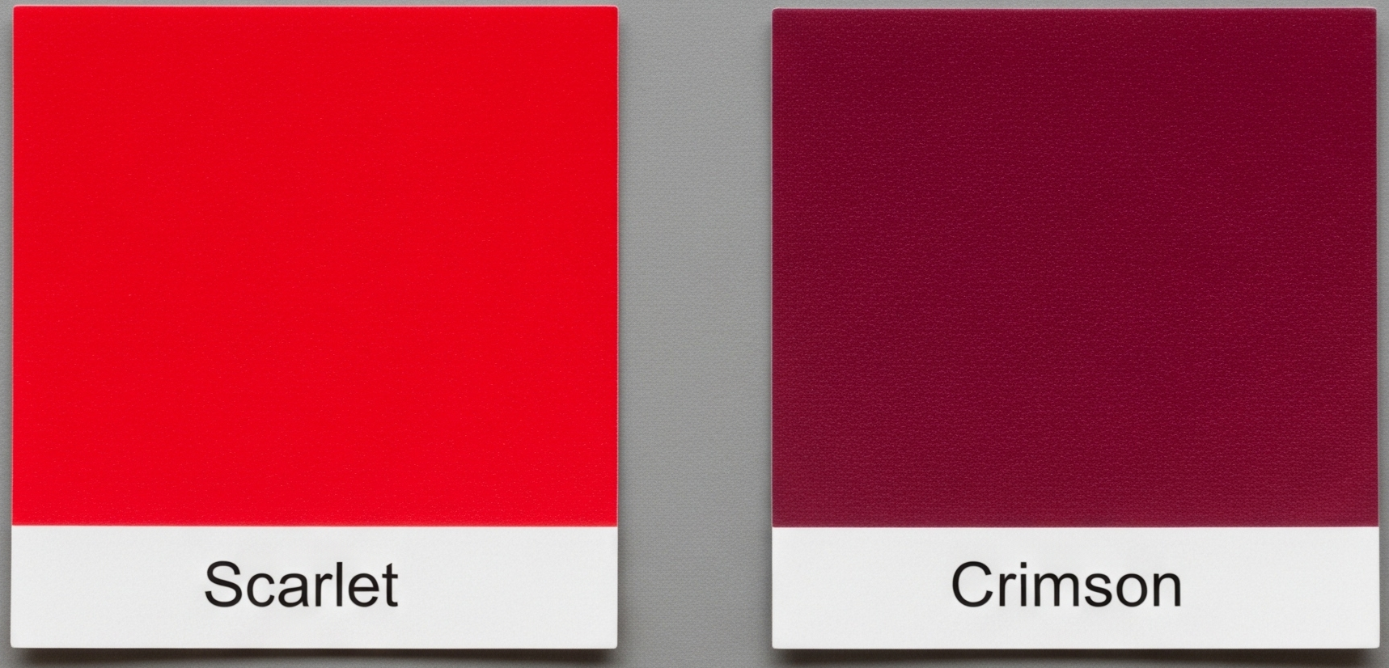

Since red can be a symbol of either life or sin then it is also a symbol of either life and good or death and evil as in Deuteronomy 30:15.

Deuteronomy 30:15
See, I have set before thee this day life and good, and death and evil;

To prove the Biblical connection between both “worm” and the “scarlet worm” we must “look behind the veil of translation” so to speak. Luckily, we don’t need to know a lick of Hebrew to do so. That work has already been done for us. Remember that every word of God is pure (Pro 30:5, Psa 12:7) and that God promised to preserve them from “this generation” for ever (Psa 12:7, Mat 24:35). The generation whose hands were used by the Holy Ghost to write the Psalms would have likely spoken and written what we call “Paleo-Hebrew” which was around well over 2,000 years before early modern English (1000BC to 586BC). And so God’s promise also includes the words that our English King James Bibles were translated from.

Strong’s numbers associated with "worm"

First appearance | Strong’s | English | Definition
Exodus 16:24 | H7415 (7x) | Worm (5x) / worms (2x) | Maggot
Job 25:6 | H8438 (43x) | Crimson (1x) / scarlet (34x) / worm (5x) / worms (3x) | Crimson grub / crimson worm / scarlet worm (Coccus ilicis) (similar, but not exactly the same as Dactylopius coccus)
Isaiah 51:8 | H5580 | Worm (1x) | Moth
Mark 9:44 | G4663 | Worm (3x) | Worms

At the end of this document are tables with every occurrence of each Strong’s number associated with the word “worm” or a phrase that ends with “worm”.

It is a Jewish and Hebrew tradition that when a person quotes the first word or verse of a text (especially but not limited to the Psalms) the implication is that they are also referencing the entire text much like we reference songs by singing/quoting the first few words or phrases (sometimes called a verse or a stanza). For example, when you see the phrase “Happy birthday to you…” your mind might automatically begin finishing the song because you are familiar with it. Important for this study: because the Psalms are songs, and Jewish people would be intimately familiar with them, when Jesus quoted Psalm 22:1 it would call to mind the entire Psalm to the Jewish people around Him. And when we do so, it becomes strikingly obvious that the vast majority of Psalm 22 couldn’t possibly be about David.

And so the story of the Mamma scarlet worm begins…

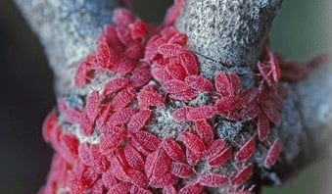Young adult Coccus ilicis
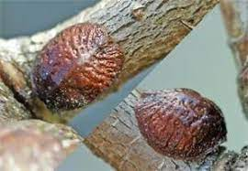Female Coccus ilicis before giving birth

Say hello to the scarlet worm: also known as Jesus.

Psalms 22:1-10
1 My God, my God, why hast thou forsaken me? (Matthew 27:46, Mark 15:34) why art thou so far from helping me, and from the words of my roaring?
2 O my God, I cry in the daytime, but thou hearest not; and in the night season, and am not silent.
3 But thou art holy, O thou that inhabitest the praises of Israel.
4 Our fathers trusted in thee: they trusted, and thou didst deliver them.
5 They cried unto thee, and were delivered: they trusted in thee, and were not confounded.
6 But I am a worm^{H8438}, and no man; a reproach of men, and despised of the people.
7 All they that see me laugh me to scorn: they shoot out the lip, they shake the head, saying,
8 He trusted on the LORD that he would deliver him: let him deliver him, seeing he delighted in him.
9 But thou art he that took me out of the womb: thou didst make me hope when I was upon my mother's breasts.
10 I was cast upon thee from the womb: thou art my God from my mother's belly.

In an acceptable time, and in a day of salvation when Mamma scarlet worm was ready to give birth

Ezekiel 36:26
A new heart also will I give you, and a new spirit will I put within you: and I will take away the stony heart out of your flesh, and I will give you an heart of flesh.

Isaiah 49:8-9
8 Thus saith the LORD, In an acceptable time have I heard thee, and in a day of salvation have I helped thee: and I will preserve thee, and give thee for a covenant of the people, to establish the earth, to cause to inherit the desolate heritages;
9 That thou mayest say to the prisoners, Go forth; to them that are in darkness, Shew yourselves. They shall feed in the ways, and their pastures shall be in all high places.
- Remember that a testament (Hebrews 9:18) or covenant requires blood.
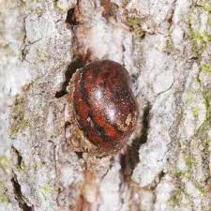Female Kermes ilicis forming a protective shell to lay her eggs

She attached herself to a tree and formed a protective shell around herself and her soon-to-be young. She then begat her eggs in the safety of the protective shell.

John 19:16-18
16 Then delivered he him therefore unto them to be crucified. And they took Jesus, and led him away.
17 And he bearing his cross went forth into a place called the place of a skull, which is called in the Hebrew Golgotha:
18 Where they crucified him, and two other with him, on either side one, and Jesus in the midst.

1 Peter 2:24
Who his own self bare our sins in his own body on the tree, that we, being dead to sins, should live unto righteousness: by whose stripes ye were healed.

1 Peter 1:3
Blessed be the God and Father of our Lord Jesus Christ, which according to his abundant mercy hath begotten us again unto a lively hope by the resurrection of Jesus Christ from the dead,

James 1:18
Of his own will begat he us with the word of truth, that we should be a kind of firstfruits of his creatures.

John 1:12-13
12 But as many as received him, to them gave he power to become the sons of God, even to them that believe on his name:
13 Which were born, not of blood, nor of the will of the flesh, nor of the will of man, but of God.

Mark 1:8
I indeed have baptized you with water: but he shall baptize you with the Holy Ghost.

John 3:5
Jesus answered, Verily, verily, I say unto thee, Except a man be born of water and of the Spirit, he cannot enter into the kingdom of God.

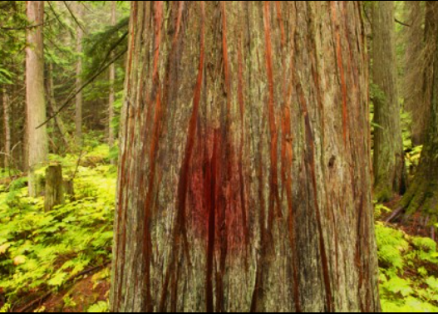Tree stained with Coccus ilicis dye

After laying her eggs and dying on the tree, her body becomes essential nutrition for her young. As her young feast and grow, the red dye that was in her body also permanently identifies her children as her own. Her death is transformed into life for her children.

John 6:53-55
53 Then Jesus said unto them, Verily, verily, I say unto you, Except ye eat the flesh of the Son of man, and drink his blood, ye have no life in you.
54 Whoso eateth my flesh, and drinketh my blood, hath eternal life; and I will raise him up at the last day.
55 For my flesh is meat indeed, and my blood is drink indeed.

1 Peter 2:2
As newborn babes, desire the sincere milk of the word, that ye may grow thereby:

Revelation 19:13
And he was clothed with a vesture dipped in blood: and his name is called The Word of God.

Ephesians 1:13
In whom ye also trusted, after that ye heard the word of truth, the gospel of your salvation: in whom also after that ye believed, ye were sealed with that holy Spirit of promise,

2 Corinthians 1:20-22
20 For all the promises of God in him are yea, and in him Amen, unto the glory of God by us.
21 Now he which stablisheth us with you in Christ, and hath anointed us, is God;
22 Who hath also sealed us, and given the earnest of the Spirit in our hearts.

Revelation 1:5
And from Jesus Christ, who is the faithful witness, and the first begotten of the dead, and the prince of the kings of the earth. Unto him that loved us, and washed us from our sins in his own blood,

2 Corinthians 5:21
For he hath made him to be sin for us, who knew no sin; that we might be made the righteousness of God in him.

Even after her young hatch, they stay within her protective shell, shielded from the wrath to come and given life abundantly.

1 Thessalonians 1:10 (Matthew 3:7, Luke 3:7)
And to wait for his Son from heaven, whom he raised from the dead, even Jesus, which delivered us from the wrath to come.

John 10:10
The thief cometh not, but for to steal, and to kill, and to destroy: I am come that they might have life, and that they might have it more abundantly.

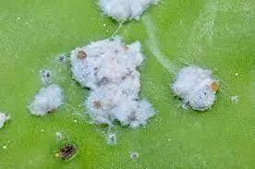(Likely) a Dactylopius coccus mother after death (very similar to Coccus ilicis)

A few days after dying, her young still protected by her sacrifice, her body becomes white and fluffy like wool. This change makes her young look different from above and protects them from potential predators.

Isaiah 1:18
Come now, and let us reason together, saith the LORD: though your sins be as scarlet, they shall be as white as snow; though they be red like crimson^{H8438}, they shall be as wool.

1 John 1:9
If we confess our sins, he is faithful and just to forgive us our sins, and to cleanse us from all unrighteousness.

1 Peter 5:8
Be sober, be vigilant; because your adversary the devil, as a roaring lion, walketh about, seeking whom he may devour:

And with that, the life cycle of the crimson worm begins again. It is a living creature that God created that is also a living reminder of what God did for us.

Search results for "H7415" (maggot)

Exo 16:24 | And they laid it up till the morning, as Moses bade: and it did not stink, neither was there any wormH7415 therein.
Job 7:5 | My flesh is clothed with wormsH7415 and clods of dust; my skin is broken, and become loathsome.
Job 17:14 | I have said to corruption, Thou art my father: to the wormH7415, Thou art my mother, and my sister.
Job 21:26 | They shall lie down alike in the dust, and the wormsH7415 shall cover them.
Job 24:20 | The womb shall forget him; the wormH7415 shall feed sweetly on him; he shall be no more remembered; and wickedness shall be broken as a tree.
Job 25:6 | How much less man, that is a wormH7415? and the son of man, which is a worm?
Isa 14:11 | Thy pomp is brought down to the grave, and the noise of thy viols: the wormH7415 is spread under thee, and the worms cover thee.

Search results for "H8438" (scarlet worm)
Exo 16:20 | Notwithstanding they hearkened not unto Moses; but some of them left of it until the morning, and it bred wormsH8438, and stank: and Moses was wroth with them.
Exo 25:4 | And blue, and purple, and scarletH8438 H8144, and fine linen, and goats' hair,
Exo 26:1 | Moreover thou shalt make the tabernacle with ten curtains of fine twined linen, and blue, and purple, and scarletH8144 H8438: with cherubims of cunning work shalt thou make them.
Exo 26:31 | And thou shalt make a vail of blue, and purple, and scarletH8144 H8438, and fine twined linen of cunning work: with cherubims shall it be made:
Exo 26:36 | And thou shalt make an hanging for the door of the tent, of blue, and purple, and scarletH8438 H8144, and fine twined linen, wrought with needlework.
Exo 27:16 | And for the gate of the court shall be an hanging of twenty cubits, of blue, and purple, and scarletH8144 H8438, and fine twined linen, wrought with needlework: and their pillars shall be four, and their sockets four.
Exo 28:5 | And they shall take gold, and blue, and purple, and scarletH8144 H8438, and fine linen.
Exo 28:6 | And they shall make the ephod of gold, of blue, and of purple, of scarletH8144 H8438, and fine twined linen, with cunning work.
Exo 28:8 | And the curious girdle of the ephod, which is upon it, shall be of the same, according to the work thereof; even of gold, of blue, and purple, and scarletH8144 H8438, and fine twined linen.
Exo 28:15 | And thou shalt make the breastplate of judgment with cunning work; after the work of the ephod thou shalt make it; of gold, of blue, and of purple, and of scarletH8144 H8438, and of fine twined linen, shalt thou make it.
Exo 28:33 | And beneath upon the hem of it thou shalt make pomegranates of blue, and of purple, and of scarletH8144 H8438, round about the hem thereof; and bells of gold between them round about:
Exo 35:6 | And blue, and purple, and scarletH8144 H8438, and fine linen, and goats' hair,
Exo 35:23 | And every man, with whom was found blue, and purple, and scarletH8144 H8438, and fine linen, and goats' hair, and red skins of rams, and badgers' skins, brought them.
Exo 35:25 | And all the women that were wise hearted did spin with their hands, and brought that which they had spun, both of blue, and of purple, and of scarletH8144 H8438, and of fine linen.
Exo 35:35 | Them hath he filled with wisdom of heart, to work all manner of work, of the engraver, and of the cunning workman, and of the embroiderer, in blue, and in purple, in scarletH8144 H8438, and in fine linen, and of the weaver, even of them that do any work, and of those that devise cunning work.
Exo 36:8 | And every wise hearted man among them that wrought the work of the tabernacle made ten curtains of fine twined linen, and blue, and purple, and scarletH8144 H8438: with cherubims of cunning work made he them.
Exo 36:35 | And he made a vail of blue, and purple, and scarletH8144 H8438, and fine twined linen: with cherubims made he it of cunning work.
Exo 36:37 | And he made an hanging for the tabernacle door of blue, and purple, and scarletH8144 H8438, and fine twined linen, of needlework;
Exo 38:18 | And the hanging for the gate of the court was needlework, of blue, and purple, and scarletH8144 H8438, and fine twined linen: and twenty cubits was the length, and the height in the breadth was five cubits, answerable to the hangings of the court.
Exo 38:23 | And with him was Aholiab, son of Ahisamach, of the tribe of Dan, an engraver, and a cunning workman, and an embroiderer in blue, and in purple, and in scarletH8144 H8438, and fine linen.
Exo 39:1 | And of the blue, and purple, and scarletH8144 H8438, they made cloths of service, to do service in the holy place, and made the holy garments for Aaron; as the LORD commanded Moses.
Exo 39:2 | And he made the ephod of gold, blue, and purple, and scarletH8438 H8144, and fine twined linen.
Exo 39:3 | And they did beat the gold into thin plates, and cut it into wires, to work it in the blue, and in the purple, and in the scarletH8144 H8438, and in the fine linen, with cunning work.
Exo 39:5 | And the curious girdle of his ephod, that was upon it, was of the same, according to the work thereof; of gold, blue, and purple, and scarletH8144 H8438, and fine twined linen; as the LORD commanded Moses.
Exo 39:8 | And he made the breastplate of cunning work, like the work of the ephod; of gold, blue, and purple, and scarletH8144 H8438, and fine twined linen.
Exo 39:24 | And they made upon the hems of the robe pomegranates of blue, and purple, and scarletH8144 H8438, and twined linen.
Exo 39:29 | And a girdle of fine twined linen, and blue, and purple, and scarletH8144 H8438, of needlework; as the LORD commanded Moses.
Lev 14:4 | Then shall the priest command to take for him that is to be cleansed two birds alive and clean, and cedar wood, and scarletH8144 H8438, and hyssop:
Lev 14:6 | As for the living bird, he shall take it, and the cedar wood, and the scarletH8144 H8438, and the hyssop, and shall dip them and the living bird in the blood of the bird that was killed over the running water:
Lev 14:49 | And he shall take to cleanse the house two birds, and cedar wood, and scarletH8144 H8438, and hyssop:
Lev 14:51 | And he shall take the cedar wood, and the hyssop, and the scarletH8144 H8438, and the living bird, and dip them in the blood of the slain bird, and in the running water, and sprinkle the house seven times:
Lev 14:52 | And he shall cleanse the house with the blood of the bird, and with the running water, and with the living bird, and with the cedar wood, and with the hyssop, and with the scarletH8144 H8438:
Num 4:8 | And they shall spread upon them a cloth of scarletH8438 H8144, and cover the same with a covering of badgers' skins, and shall put in the staves thereof.
Num 19:6 | And the priest shall take cedar wood, and hyssop, and scarletH8438 H8144, and cast it into the midst of the burning of the heifer.
Deu 28:39 | Thou shalt plant vineyards, and dress them, but shalt neither drink of the wine, nor gather the grapes; for the wormsH8438 shall eat them.
Job 25:6 | How much less man, that is a worm? and the son of man, which is a wormH8438?
Psa 22:6 | But I am a wormH8438, and no man; a reproach of men, and despised of the people.
Isa 1:18 | Come now, and let us reason together, saith the LORD: though your sins be as scarlet, they shall be as white as snow; though they be red like crimsonH8438, they shall be as wool.
Isa 14:11 | Thy pomp is brought down to the grave, and the noise of thy viols: the worm is spread under thee, and the wormsH8438 cover thee.
Isa 41:14 | Fear not, thou wormH8438 Jacob, and ye men of Israel; I will help thee, saith the LORD, and thy redeemer, the Holy One of Israel.
Isa 66:24 | And they shall go forth, and look upon the carcases of the men that have transgressed against me: for their wormH8438 shall not die, neither shall their fire be quenched; and they shall be an abhorring unto all flesh.
Lam 4:5 | They that did feed delicately are desolate in the streets: they that were brought up in scarletH8438 embrace dunghills.
Jon 4:7 | But God prepared a wormH8438 when the morning rose the next day, and it smote the gourd that it withered.

Search results for "H5580" (moth)

Isa 51:8 | For the moth shall eat them up like a garment, and the wormH5580 shall eat them like wool: but my righteousness shall be for ever, and my salvation from generation to generation.

Search results for "G4663" (worms)

Mar 9:44 | Where their wormG4663 dieth not, and the fire is not quenched.
Mar 9:46 | Where their wormG4663 dieth not, and the fire is not quenched.
Mar 9:48 | Where their wormG4663 dieth not, and the fire is not quenched.

